`

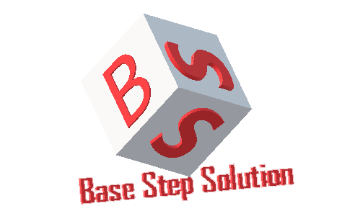

Meeting Minutes

Van Lang Admissions

# Revision Table

|  |  |  |  |
| --- | --- | --- | --- |
| Author | Date | Reason for changes | Version |
| Khoi Nguyen | 21/12/2016 | Initial Document | 1.0 |

Table of Contents

Revision Table 1

I. Purpose 3

II. Participant in meeting 3

III. Content of meeting 3

IV. To do task 4

|  |  |  |  |  |  |
| --- | --- | --- | --- | --- | --- |
| **Writer:** | Khởi Nguyễn | **Location:** | Room 701C | | |
| **Date:** | 21/12/2016 | **Start:** | 13h00 | **Finish:** | 15h00 |

# Purpose

Review Quality Attributes

# participant in meeting

Customer : Lecturer Nguyễn Thế Quang

Nhóm Capston:

* Nguyễn Thái Hiền
* Nguyễn Hoàng Anh Tài
* Đoàn Anh Minh
* Trần Xuân Hải
* Nguyễn Anh Khởi
* Nguyễn Xuân Thái Hiền

# Content of meeting

* SQA-P01 : response what ?? 2 second with how much data? Where is the access data? Where is the most important ? banner , youtube , event ...how to load? How much system? What is the smallest bandwidth? Access by 3G or not?
* Kịch bản phải đo lường rõ ràng ! đối với nơi dữ liệu nhiều nhất. ( qua 3G , mobile có còn đúng 2s hay không ?
* SQA-P02 : 1000 record – normal is 4-5000 record 4s - response : Returns information on which data was successfully entered into the database, and how measured.
* SQA-A01 : Speaking of operation: what is the crash, what does it feedback and how long does it take to recover? (For operator)
* SQA-C01 : artifact not code , scalability : 2 types . purpose of notbalancing is increase resouces to meet incoming connections ( Stretch, expand, can run on more servers ...)
* I do not need to keep data memory
* SQA-U01 : Reponsive on mobile , UI , UX ( must meet ) decision : use boottrap To look on the mobile
* SQA-R01 : deploy on mobile , use ionit framwork
* SQA-M01 : modify clearly ,Environment : build -> design time , artifact : wrong . Users want to run on another platform: change the UI. How many days to develop, how many hours, how many resources, how many?
* SQA-S01 : outside not login , create pass , encoding pass
* Use-case post view : add button save

# To do task

* Complete Architecture

---- *** ----